SOFTWARE ENGINEERING PROJECT
GROUP B
- REX SCOTT -221719
- MATHINI DANIEL -192295
- ASHLYN ARINGO -185115

CampusFix
Campus Maintenance, Lost-and-Found and Vehicle Sticker Portal
Deliverable 1: Planning / Requirements Analysis | Deliverable 2: Systems Analysis & Design (Use Case, Class and E-R Diagrams)

DELIVERABLE 1: PLANNING / REQUIREMENTS ANALYSIS
1.1 Project Title
CampusFix: A Standalone Campus Services Portal for Strathmore University.

1.2 Brief Description of the System
CampusFix is a standalone web-based campus-services information system. Students and lecturers report campus maintenance problems (for example a faulty projector, leaking tap or broken desk), follow repairs, post lost-and-found notices, and request campus vehicle stickers. Chania is referenced only as an example of a similar system; CampusFix does not connect to Chania or any university production service.
The system has three parts, as required by the project guidelines:
- Front-end: students and lecturers register, log in, report maintenance issues with a location and optional photo, post lost/found notices, request vehicle stickers, track progress, and confirm or rate repairs.
- Admin panel and staff interface: supervisors review reported issues, set priority and deadlines, and assign technicians; technicians see tasks and update progress; staff review lost/found matches and vehicle sticker applications; administrators manage users, categories, campus locations, reports, and audit history.
- Database: a relational database stores users, issues, assignments, work logs, feedback, maintenance and service notifications, audit logs, lost/found notices and claims, vehicle registrations, password resets, and campus locations.
Main transaction: a reporter submits a maintenance issue, a supervisor assigns it to a technician, the technician records work until resolution, and the reporter confirms the fix. Separate campus-services workflows handle lost/found claims and vehicle sticker approval.

1.3 Group Members and Assigned Tasks
Replace the placeholders below with your group's names and admission numbers. The last row is already filled in as an example of how to record your part.
Member name | Admission no. | Tasks assigned
Rex Scott | 221719 | Front-end development (reporter interface); UI mockups for the front-end
Daniel Mathini | 192295 | Admin panel development; UI mock-ups for the admin panel; reports
Ashlyn Aringo | 185115 | Database schema and database creation; backend connection

1.4 Functional Requirements
FR1: User accounts and access levels. The system shall let users register, log in, log out and reset a forgotten password, and shall give each user access only to the functions of their role (student, lecturer, technician, supervisor, administrator).
FR2: Report an issue. A student or lecturer shall be able to report a maintenance issue by choosing a category, selecting the building and room, describing the problem and optionally attaching a photo. The system shall give each report a unique ticket number and shall let the reporter edit or cancel it while it is still pending.
FR3: Review and assign issues. A supervisor shall be able to view and filter all reported issues, set a
priority and deadline, and assign an issue to an available technician. The assigned technician shall be notified.
FR4: Resolve, notify and track. A technician shall be able to view assigned tasks, change the status (Assigned, In Progress, Resolved) and add work notes. The reporter shall be notified of each status change by email or SMS, shall be able to track the issue at any time, and shall be able to confirm the fix and rate the service.
FR5: Administration, reports and audit trail. Administrators shall be able to add, edit, delete and search users, categories, buildings and rooms; view the audit log; and generate branded reports carrying the configured organization name and generated date, filterable and sortable by date, category, location, status and technician.
FR6: Lost and found. Students and lecturers shall be able to post lost or found notices and submit possible matches. Staff shall review match claims, and the notice owner shall be able to mark an approved match as returned.
FR7: Vehicle stickers. Students and lecturers shall be able to submit vehicle details for a campus sticker. Supervisors or administrators shall approve or reject requests; approved requests shall receive a unique sticker number and notify the requester.

1.5 Non-Functional Requirements
NFR1: Security. Passwords shall be stored as salted hashes, all database queries shall use prepared statements to prevent SQL injection, and every session shall be controlled by role-based access. Twofactor authentication shall be available for administrator and supervisor accounts.
NFR2: Usability and performance. The system shall be easy to use for first-time users, with a consistent layout, clear error messages and help text, and shall work on both desktop and mobile browsers. Common pages shall load within 3 seconds on the campus network.
NFR3: Reliability and availability. The system shall be available during the working hours of the university term, shall take daily database backups, and shall keep data consistent so that a report is never lost or duplicated if an operation fails.

DELIVERABLE 2: SYSTEMS ANALYSIS AND DESIGN

2.1 Use Case Diagram
The use-case figure shows the five roles and the core maintenance workflow. Student and Lecturer / Staff are specialisations of an abstract Reporter actor, so both can use reporter functions. Every actor must log in before using protected functions. The implementation also provides standalone lost-and-found and vehicle-sticker workflows with staff review and in-app notifications; CampusFix does not integrate with Chania.
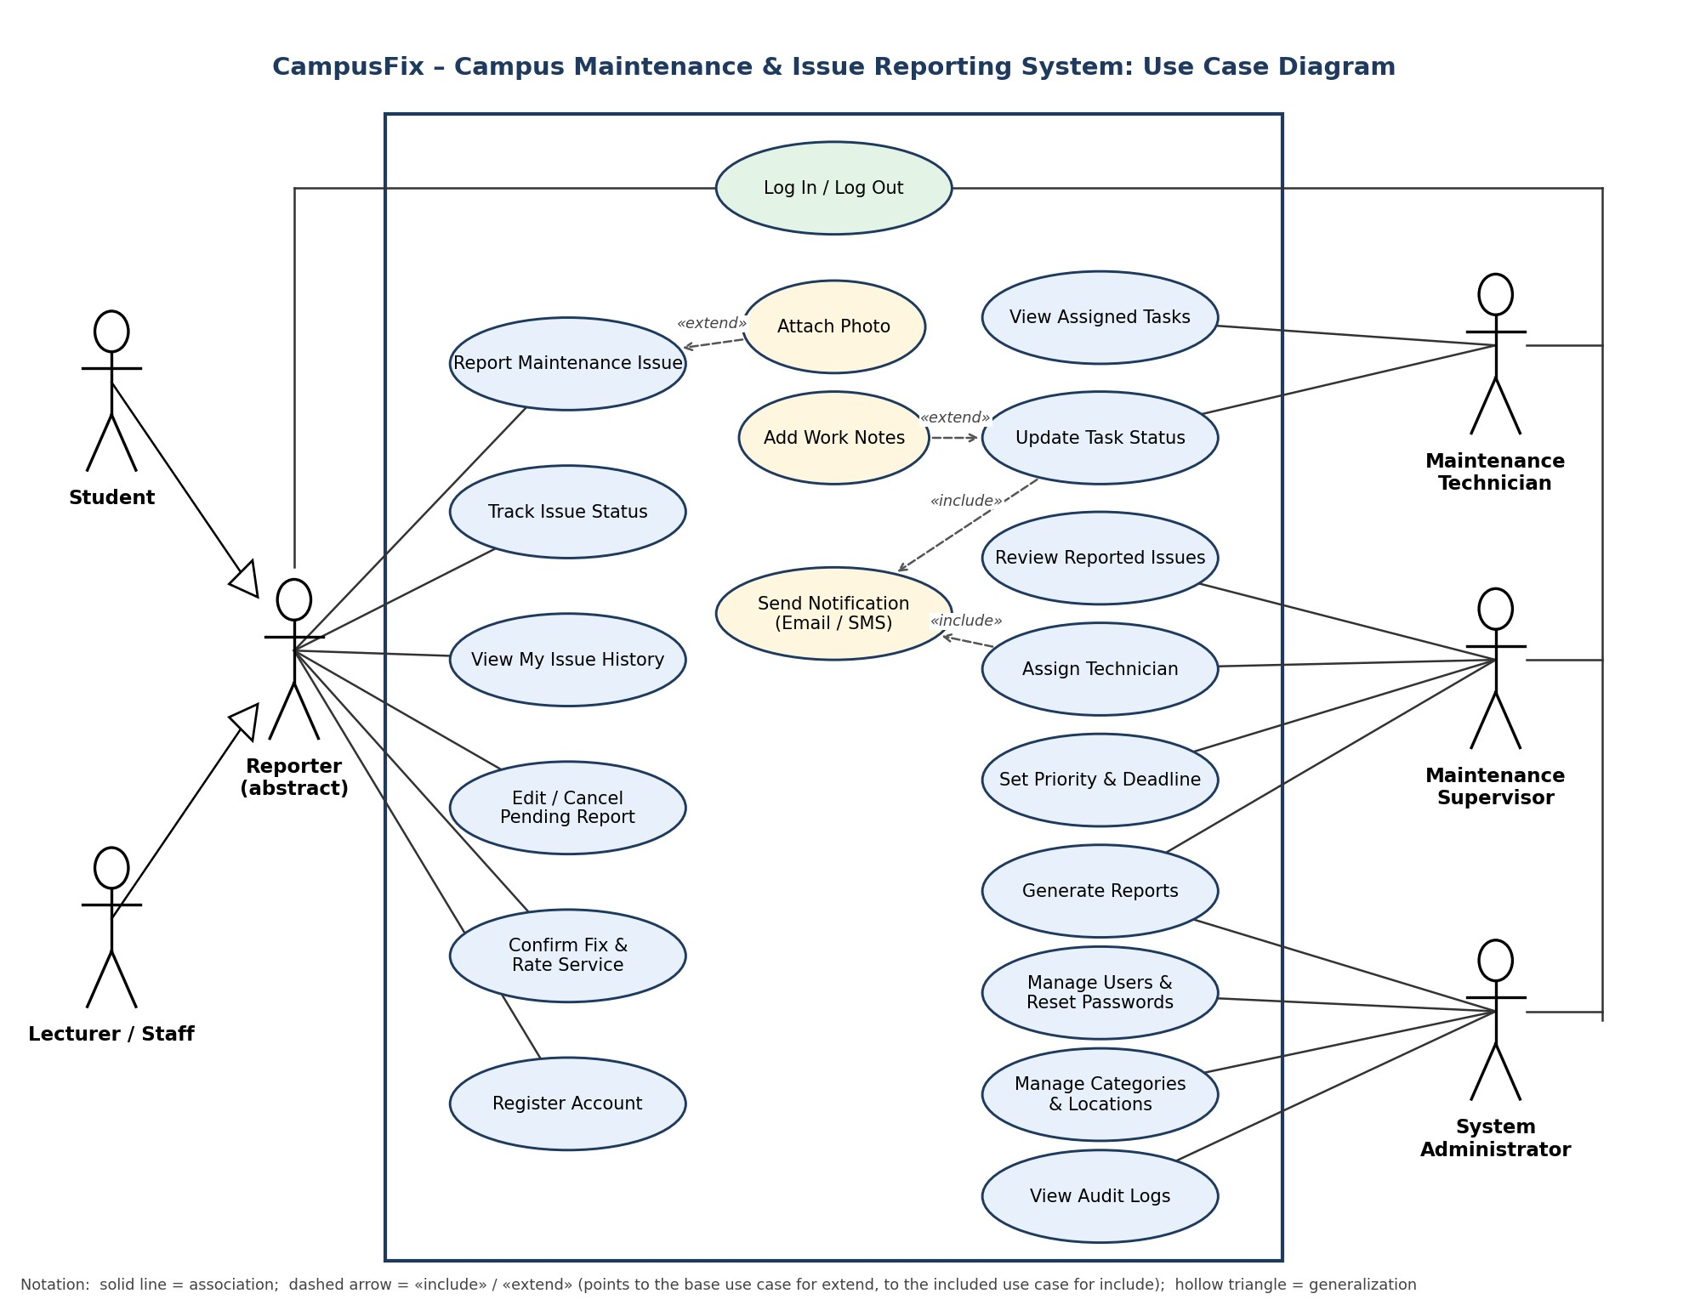
Figure 1: Use case diagram for CampusFix

Actors
Actor | Role in the system
Student | Reports and tracks maintenance issues; posts lost/found notices and possible matches; requests vehicle stickers.
Lecturer / Staff | Same maintenance and campus-service functions as a student.
Maintenance Technician | Receives assigned tasks, updates their status and records work notes.
Maintenance Supervisor | Reviews issues, assigns technicians and due dates, reviews lost/found matches and vehicle sticker applications, and views reports.
System Administrator | Manages users and campus catalogues, reviews audit history, administers account security, and generates reports.

Main use cases
Use case | Description
Report Maintenance Issue | Reporter submits an issue with category, location, description and priority suggestion. A ticket number is generated. «extend» Attach Photo.
Track Issue Status / View My Issue History | Reporter follows the current status of an issue and sees all issues they have reported.
Edit / Cancel Pending Report | Reporter changes or withdraws a report that has not yet been assigned.
Confirm Fix & Rate Service | Reporter confirms the issue is fixed and leaves a rating and comment, or reopens it.
Review Reported Issues | Supervisor views, filters and validates new reports.
Assign Technician | Supervisor assigns an issue to a technician. «include» Send Notification.
Set Priority & Deadline | Supervisor sets priority and a due date for an issue.
View Assigned Tasks | Technician sees the tasks assigned to them.
Update Task Status | Technician moves a task through Assigned, In Progress and Resolved. «include» Send Notification. «extend» Add Work Notes.
Generate Reports | Supervisor and administrator produce filtered, sortable reports with date and logo.
Manage Users & Reset Passwords | Administrator adds, edits, deactivates users and resets passwords.
Manage Categories & Locations | Administrator maintains issue categories, buildings and rooms.
View Audit Logs | Administrator reviews who performed what action and when.
Log In / Log Out; Register Account | Authentication for all actors; self-registration for students and lecturers (staff accounts are created by the administrator).

2.2 Class Diagram
The class diagram shows the main classes of CampusFix, their attributes and operations, and how they relate. User is an abstract class from which Student, Lecturer, Technician, Supervisor and Administrator inherit. An Issue is reported by a User, belongs to one Category and happens at one Location (which belongs to a Building). An Issue may have many Attachments, Assignments and Notifications and at most one Feedback. An Assignment links an Issue to a Technician and to the Supervisor who made the assignment, and holds the WorkLog entries written while the work is done. The filled diamonds show composition: Attachments, WorkLogs and Locations cannot exist without their parent.
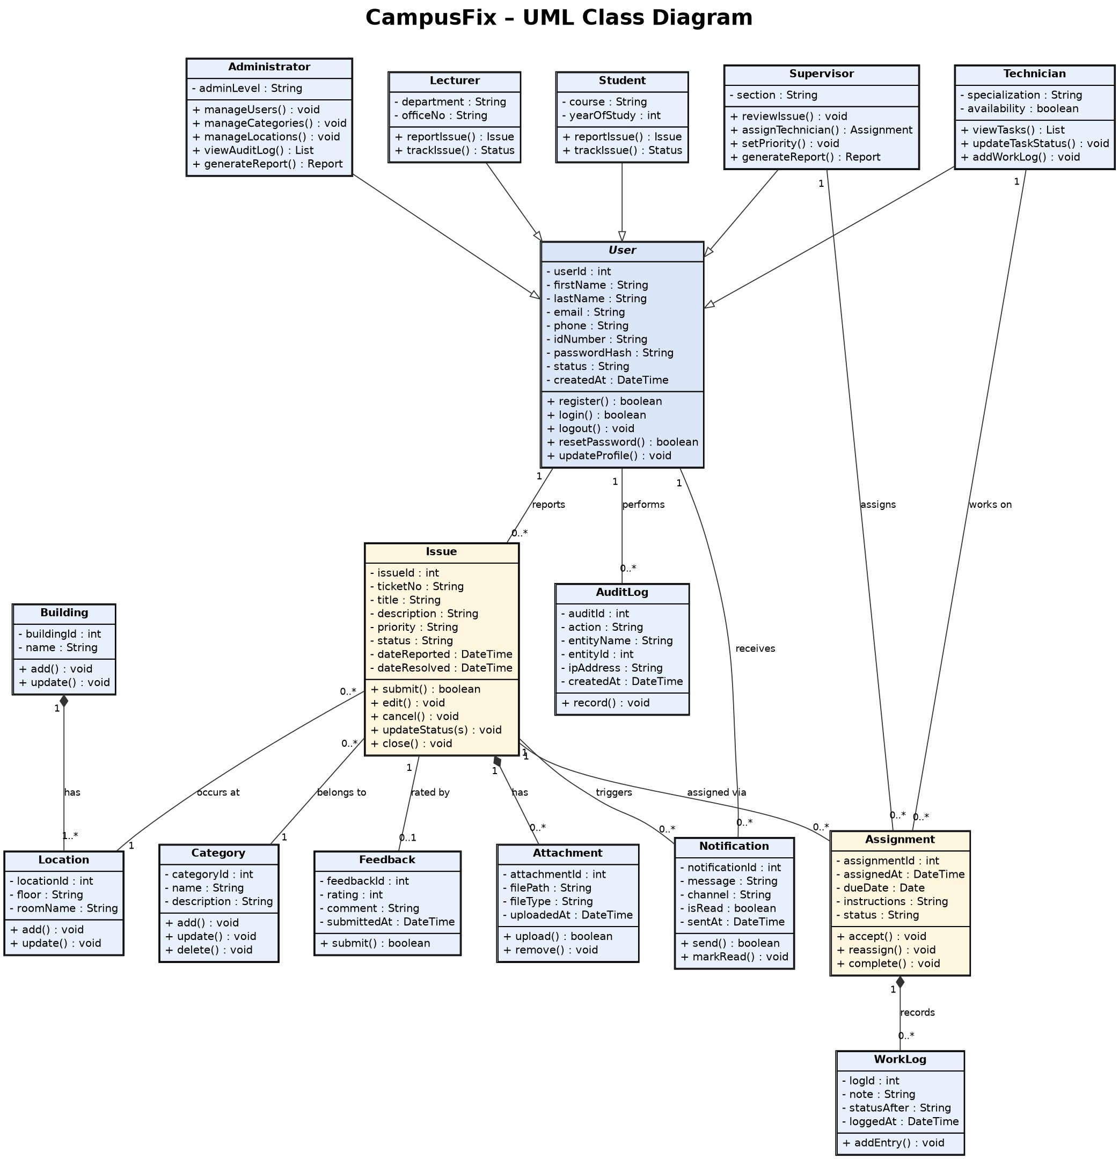
Figure 2: UML class diagram for CampusFix

2.3 Entity-Relationship (E-R) Diagram
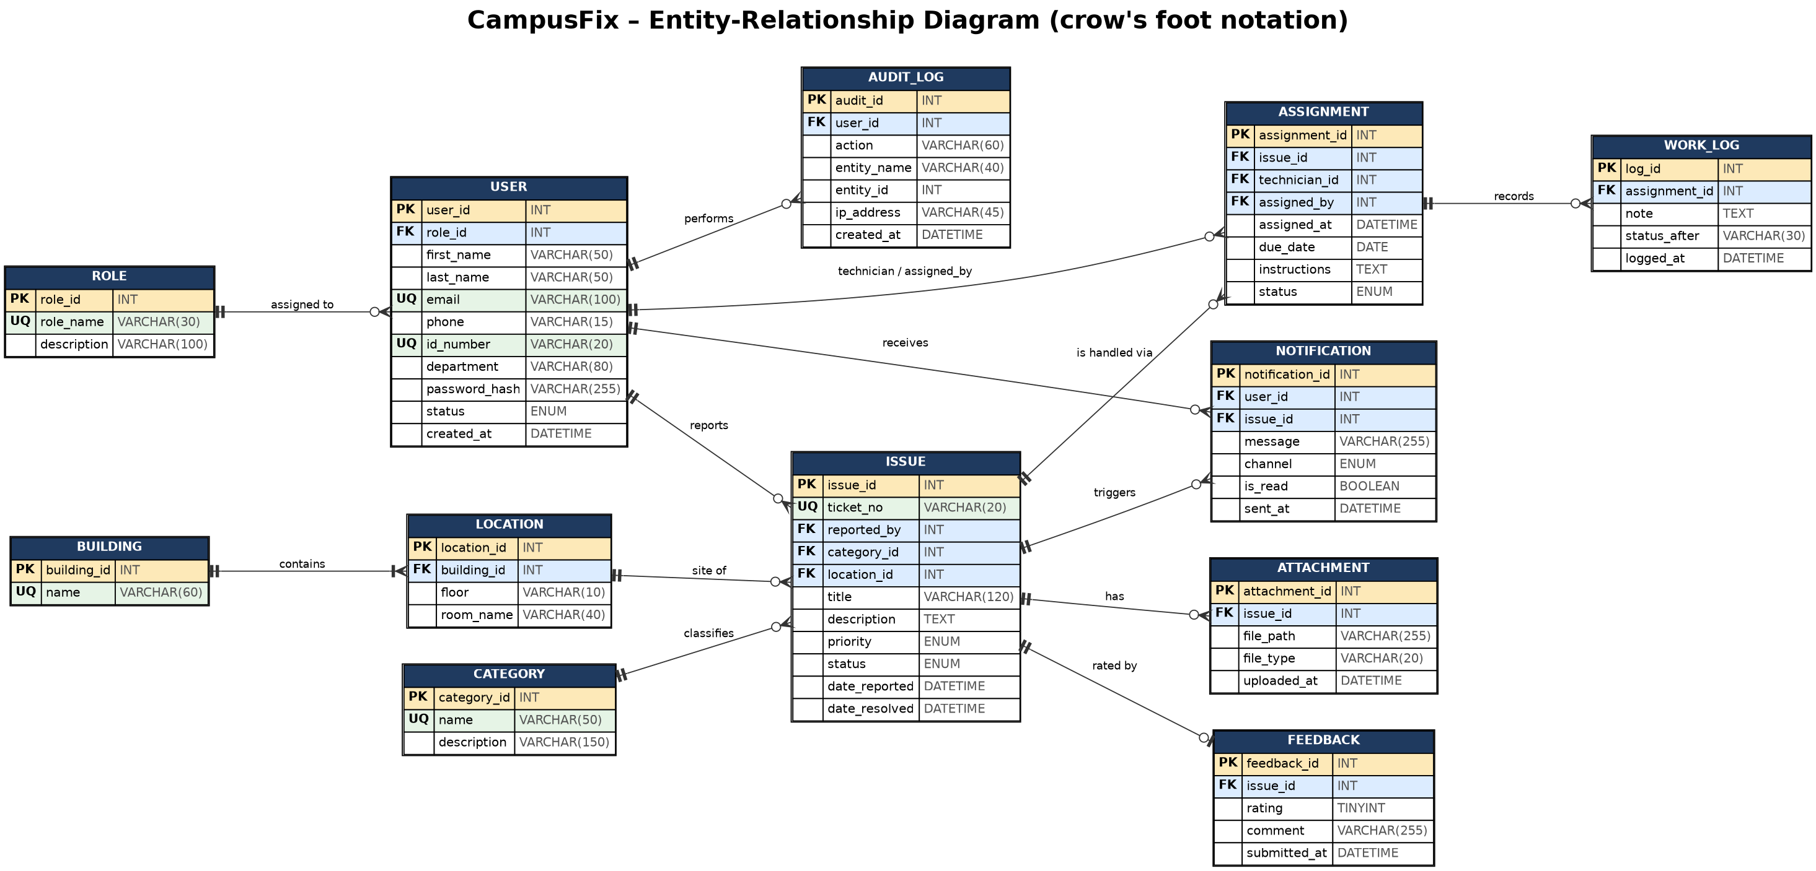
Figure 3: E-R diagram for CampusFix (crow's foot notation; PK = primary key, FK = foreign key, UQ = unique)

Entities and relationships
The E-R diagram uses crow's foot notation. A bar means "exactly one", a circle means "zero", and the threepronged foot means "many".
Relationship | Cardinality | Meaning
ROLE – USER | 1 : M | A role is held by many users; each user has exactly one role.
USER – ISSUE (reported_by) | 1 : M | A user can report many issues; each issue is reported by exactly one user.
CATEGORY – ISSUE | 1 : M | Each issue has one category; a category has many issues.
BUILDING – LOCATION | 1 : M | A building has one or more rooms; each room is in one building.
LOCATION – ISSUE | 1 : M | Each issue is at one location; a location can have many issues over time.
ISSUE – ATTACHMENT | 1 : M | An issue can have many photos or files.
ISSUE – ASSIGNMENT | 1 : M | An issue can be assigned more than once (for example on reassignment).
USER – ASSIGNMENT  (technician_id, assigned_by) | 1 : M (two links) | A technician can have many assignments; a supervisor can make many assignments. Both are foreign keys to USER.
ASSIGNMENT – WORK_LOG | 1 : M | Many progress notes are recorded for one assignment.
ISSUE – FEEDBACK | 1 : 0..1 | An issue has at most one rating, given after it is resolved.
USER – NOTIFICATION | 1 : M | A user receives many notifications.
ISSUE – NOTIFICATION | 1 : M | An issue triggers many notifications as its status changes.
USER – AUDIT_LOG | 1 : M | A user's actions are recorded as many audit entries.

Design notes
- Normalization: Attributes are atomic and each table has a primary key (first normal form). Every non-key attribute depends on the whole key (second normal form). Facts that belong to another entity are stored in their own tables: for example building names are in BUILDING, not repeated in LOCATION or ISSUE, and role names are in ROLE (third normal form).
- From classes to tables: The class diagram shows Student, Lecturer, Technician, Supervisor and Administrator as subclasses of User. In the database this inheritance is stored as a single USER table with a role_id that points to ROLE, which keeps queries simple and avoids many near-empty tables.
- Next step: The same table design will be written out in full (database name, data types and constraints) in the separate database schema deliverable.

2.4 Flow Chart Diagram
The flowchart below illustrates the workflow of the CampusFix system, from reporting a campus maintenance issue to its resolution. It shows the steps followed by students and lecturers when submitting reports, how the system validates and records the information, and how administrators review and assign issues to maintenance staff. It also demonstrates how the status of an issue is updated until the problem is resolved. This flowchart provides a visual representation of the system's operations and guides the development of its functionality. 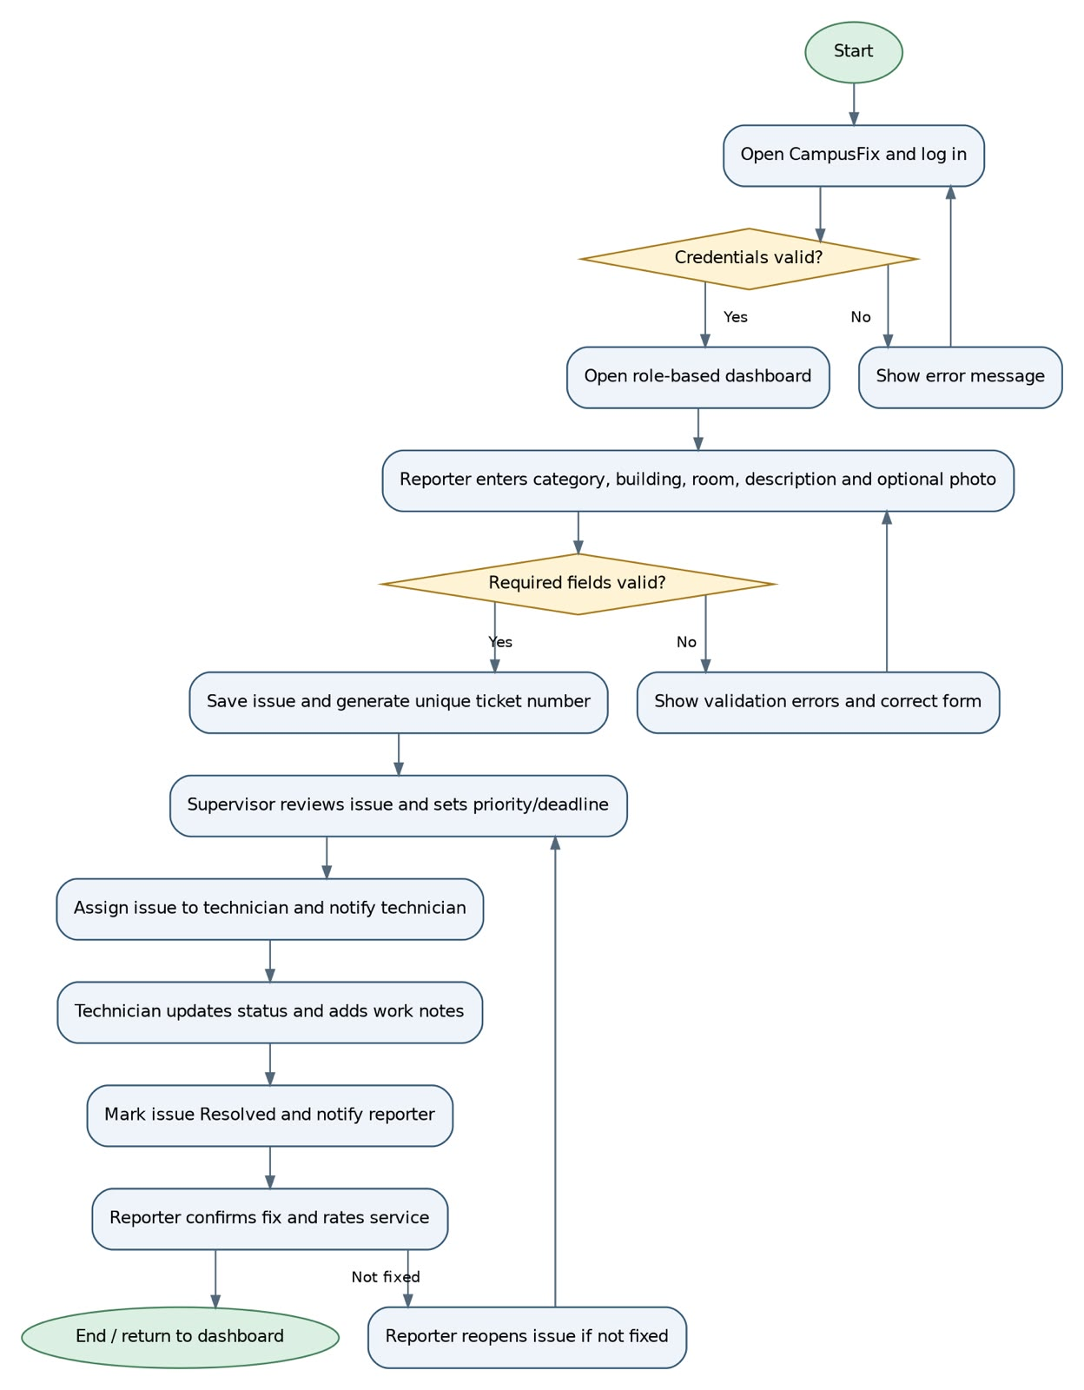

2.5. Database schema
This schema is the design used when creating the database; it is not the developed database. It states the database name, table names, all attributes with data types, primary and foreign keys and other constraints.

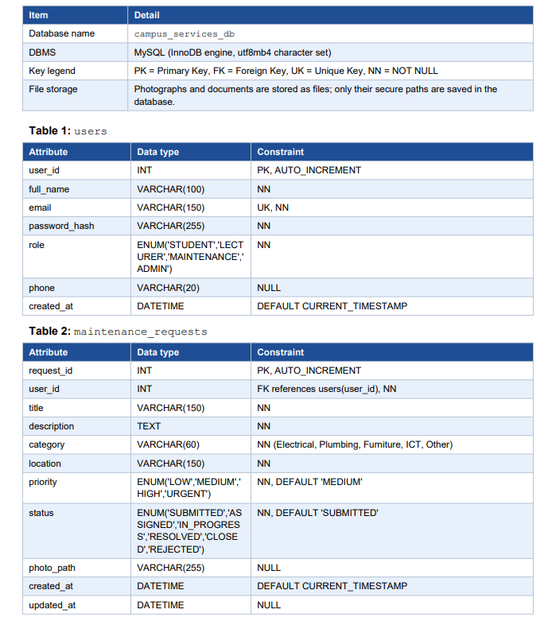

- Introduces the database design for campus_services_db: the DBMS, the key legend and how files are stored. It then defines Table 1 (users) and Table 2 (maintenance_requests) with their attributes, data types, primary and foreign keys and constraints
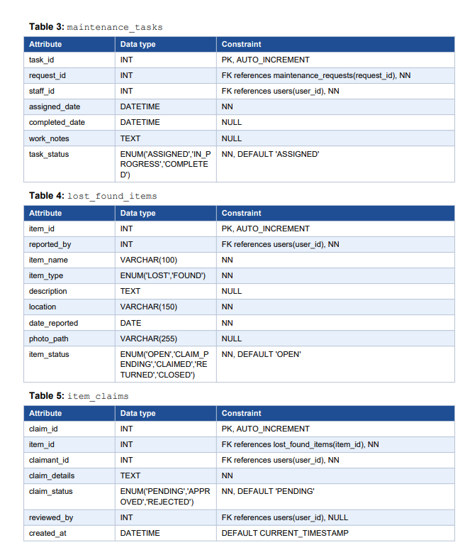

- Defines the tables that support the maintenance workflow and the lost-and-found module: maintenance_tasks, lost_found_items and item_claims. It shows each attribute’s data type, key relationships, allowed status values and defaults.
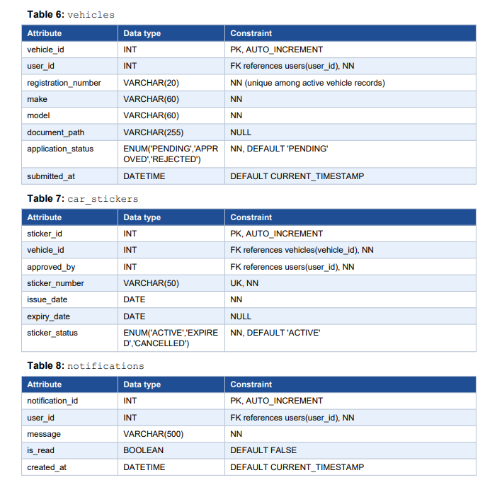

Other constraints
- Foreign keys use ON DELETE RESTRICT so that records referenced by requests, tasks, claims or stickers cannot be deleted accidentally.
- Email addresses and sticker numbers are unique; role and status columns accept only the listed ENUM values.
- Access to vehicle documents and lost-item claims is restricted to the owner and authorized administrators.
- The schema is in third normal form: each table describes one entity, and non-key attributes depend only on its primary key.

- Defines the tables for vehicle and sticker management and for notifications: vehicles, car_stickers and notifications. It closes with the other database constraints: foreign-key delete rules, unique fields, restricted access to sensitive records and third normal form.

2.6 Front-end and admin panel UI mock-ups
These are low-fidelity wireframes showing the proposed layout and controls of the front end (Mock-ups A and B) and the admin panel (Mock-up C). All figures and records shown are illustrative mock-up data, not actual Strathmore University records.

Mock-up A: User dashboard (front end)

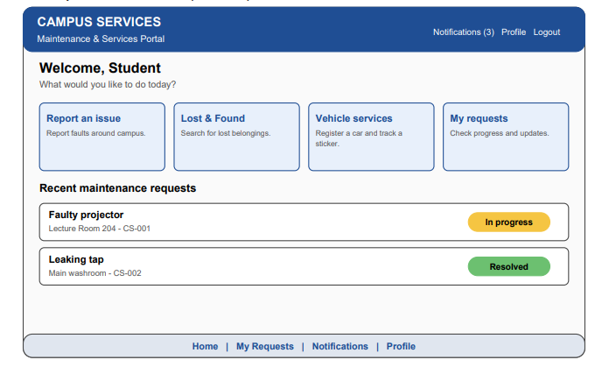

Mock-up B: Report maintenance issue (front end)
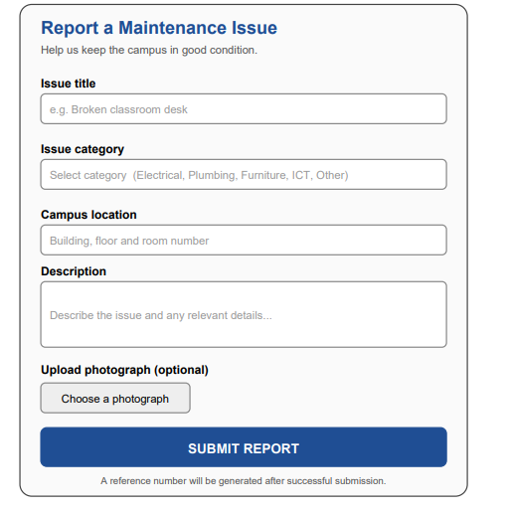

Mock-up C: Administrator dashboard (admin panel)



